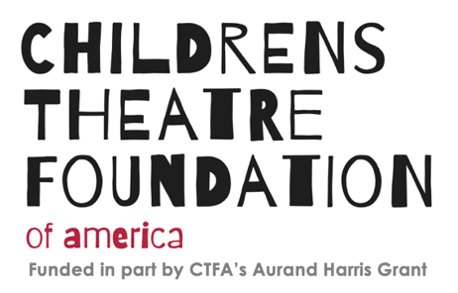
2022 CTFA AURAND HARRIS THEATRE GRANT APPLICATION – Preparation WORKSHEET
Thank you for applying for the Childrens Theatre Foundation of America’s 2022 Aurand Harris Grants for Small/Mid-Sized Theatres.
If you have any questions about the grant guidelines or this application form, please contact ctfaharrisgrant@gmail.com.
Electronic Submission Deadline: 12:00 pm PST/3:00 pm EST on Sunday, March 6, 2022.
- Email: ___________________________
- Theatre Applicant Name: _________________________
- Street address: _________________________________
- City: __________________________________________
- State: _________________________________________
- Zip Code: _______________
- Theatre phone (indicate if this is a cell number)
- Website URL, or other informational link (if available):
_________________________________
- Contact name and title (list your pronouns, if you would like to share):

- Contact email address:

- Contact Phone number (indicate if this is a cell #)

- Has your organization received a grant from CTFA during the past two years?

Check all that apply
Yes
No

- If so, please detail the year and the amount.

_________________________________________
- Date theatre applicant organization began operations: ________________________________
(example: January 7, 2019)

- Date applicant organization incorporated as a 501c3 IRS certified nonprofit:

______________________________
(example: January 7, 2019)

- Total income for your theatre’s most recent fiscal year: ______________________

- Name of project:

____________________________________________________________________

- Beginning date for proposed project (not earlier than July 1, 2022)

________________________________________

- Completion date for project (no later than August 15, 2023)

_________________________________________
(example: January 7, 2019)

- Grant Amount requested (up to $3,000.00)

___________________________________

- Project Budget including source of matching funds (use CTFA Harris budget template).
Add file

- Attach a copy of the official IRS determination letter for your 501c3 certified nonprofit status, under which you are applying.
Add file (Electronic Upload, Link)

- Describe your proposed project (200 word limit)

- How will your project impact your organization and your local audience/community? Include a description of the demographics of your intended audience/community. (400 word limit)

- Describe how your specific request /project will move EDI/anti-racism practices forward in the organization or creative work of your organization. Relate your response to the stated mission, values, EDI statement of CTFA and the 2022 stated grant focus. (300 word limit)

- Indicate specifically how CTFA funds will be spent within your total project. (one sentence)

- Attach bio(s) for primary artistic staff involved in the project.
Add file (Electronic Upload, Link)

- Thank you! Please check the box below before submitting.
This application is complete.

THIS IS THE END OF THE APPLICATION PREPARATION WORKSHEET
When you have prepared your information and gathered the requested digital files for upload, please return to the CTFA website to enter your application data into the Electronic Application Submission.

